Fitness Centre Equipment Usage Android Application

AUGFIT

AUCSC 320

Oscar Jaimes

Nathan Pellettier

Barret Sardoff

**Table of Contents**

1.0 Authors and Biographies ------------------------------------- pg 3

1.1 Oscar Jaimes

1.2 Nathan Pelletier

1.3 Barret Sardoff

2.0 Introduction ---------------------------------------------------- pg 4

3.0 Organized questions for client ------------------------------ pg 4

4.0 Wireframes ---------------------------------------------------- pg 6

4.1 Oscar Jaimes

4.2 Nathan Pelletier

4.3 Barret Sardoff

Formal Requirements Specification --------------------------- pg 9

User interface ----------------------------------------------------- pg 11

High level design ------------------------------------------------- pg 12

Architecture ------------------------------------------------------- pg 13

Coding standards adopted --------------------------------------- pg 14

Work plan ---------------------------------------------------------- pg 14

**Author List**

**Oscar Jaimes**

I am a second year computer science student at the University of Alberta Augustana faculty originally from Calgary Alberta. I first encountered programming at the age of fifteen when I started learning how to make a website using HTML, CSS, and JavaScript. Since then, I took three computing science courses in high school along with advanced placement computing science. Going into university, choosing my major as computing science was a no brainer. I have been a part of various projects for school and have worked on individual projects as well such as a desktop indie game written in Java, Rubik’s cube solver, a visualization of A* search algorithm, and many more.

Aside from my academics, I enjoy road cycling, hiking, and being in the mountains in general. I currently work part time at KFC to make some extra money during school. During the summers, I have worked at a bicycle shop as well as a computer technician for a non-profit organization.

Overall, I am very drawn to the ever expanding field that is computing science and I am always content to work on a software project, no matter how big or small.

**Nathan Tyler Pelletier**

Hello, my name is Nathan Pelletier. Currently I am a computer science major enrolled at Augustana. I love to organize, design and solve puzzles so coding makes a lot of sense to me. I’ve personally loved expanding my mind with new computer languages and coding puzzles. Computer science wasn’t always the plan though. I’ve always wanted to be a paleontologist and I’ve never stopped researching dinosaurs and ancient life. In high school I became fascinated with medical DNA research through biology, but university biology programs barred me from entry due to my lack of chemistry. Finally, I decided to pursue my love for mathematics and physics. During my first year of university I tried a computer class which I thought would be like the photoshop and movie maker classes of high school. I am so glad I was wrong.

I am more than my school experiences, however. In any given week I am actively engaged in community quires, some sort of physical activity whether it is martial arts, cardio or gym workouts. In my spare time I also write content for my friends to experience and play through in our weekly games of dungeons and dragons. Rounding out my weeks I work at Safeway in Wetaskiwin where I continue to develop my customer service skills.

**Barret Sardoff**

I am a Physics and Mathematics major at Augustana. I took a class in my first year of university in computer science and I enjoyed it so much that I promptly changed my minor to computing science. I enjoy coding as it lines up nicely with my love of math, physics and the linearity that comes with.

**Introduction**

We are AUGFIT. We are developing a fitness machine information app concerning the Augustana fitness center’s paramount machines. It is our goal to provide accurate information to the user through videos and text. We hope our information will help to reduce injuries and increase correct use of the facilities machines. Additionally, we will save options pertaining to each machine such as the weight used, the seat height and arm/leg positions. With enough time we may also add a machine use graph that tracks user progress based on weight throughout a given month.

**Organized Questions For Client**

**Q:** What problem is this application going to solve?

**A:** A lot of people injure themselves when exercising as they do not know how to use proper form on machines. This app will let people know what the correct form is via a video and instructions. The purpose of this app is to reduce injury and provide exercise knowledge to beginners.

**Q:** What is the target demographic for this app?

**A:** The general public

**Q:** Any additional features or anything that the description is missing?

**A:** A progression graph for weight used on each machine.

**Q:** Any information about the Camrose Fitness Centre put into the app?

**A:** A google maps location of the fitness centre, the hours of the centre, the location of the gym and the gym phone number

**Q:** List of all the machines desired in the application? (Only Paramount? Or all machines?)

**A:** Only the Paramount machines need a page.

**Q:** Any explanations for free weight exercises? Other exercises not involving weights? Cardio?

**A:** No. Only Paramount machines are necessary.

**Q:** Any requested order for machines?

**A:** Group by muscle group. No other sorting needed.

**Q:** What are we doing for Videos? Are copyrights an issue?

**A:** If we can get permission to use the official videos, use those. Otherwise,we will be making the videos using the machines in the fitness centre. Ensure that proper form is used.

**Q:** If we add pictures of the machines to go with the app would you prefer manufacture images or pictures taken of the machines in the fitness centre?

**A:** Pictures would be good to have. Use the manufacture pictures.

**Q:** Any sorting for machines by muscle groups, or sorting exercises by muscle group? If so which muscles should be included?

**A:** Yes. Include arms, chest, back, shoulders, lower body, and an “all” tab

**Q:** Colour Scheme and overall style?

**A:** Black, Red and White (gray if too harsh)

**4.0 Wireframes presented to client**

4.1 Oscar Jaimes Wireframes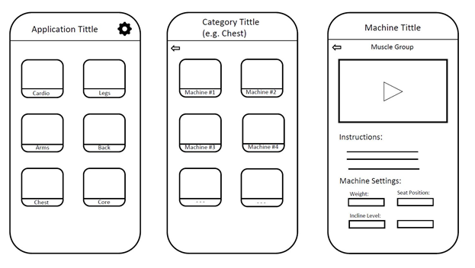

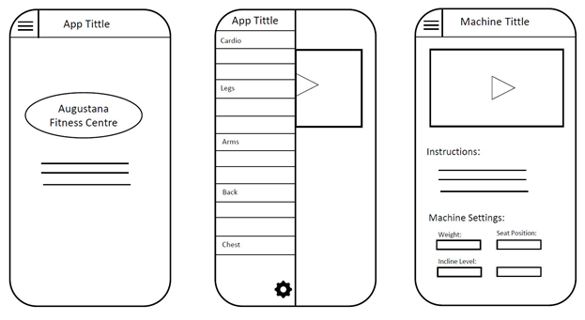

4.2 Barret’s Wireframe

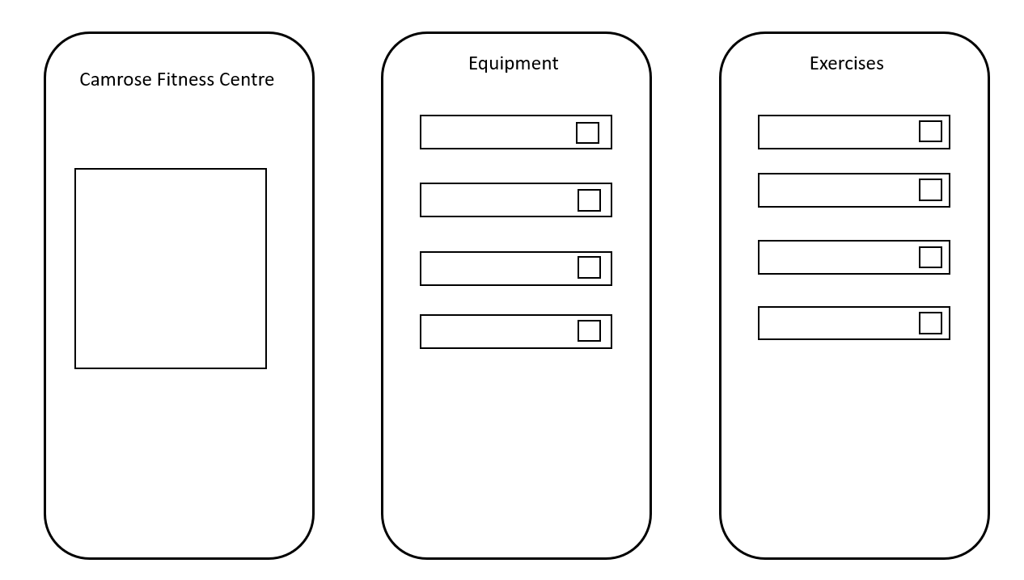

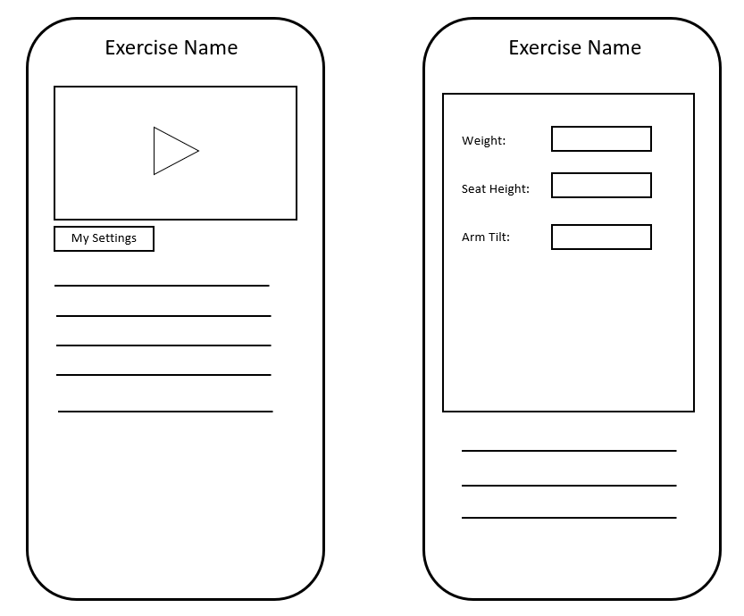

4.3 Nathan’s Wireframe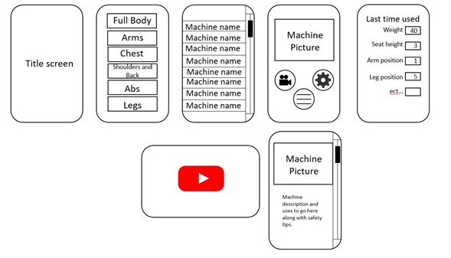

Of these wire frames presented our client chose these following circled features

Oscars general menu style and button layout.

Nathans separate option menu with one wrinkle. Our client wished for a popup menu.

She also liked Barrets loading screen idea.

On top of theses wireframes our client wished for a facility information page, which included a google map view of the building, and a graph of the user’s progress.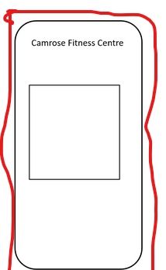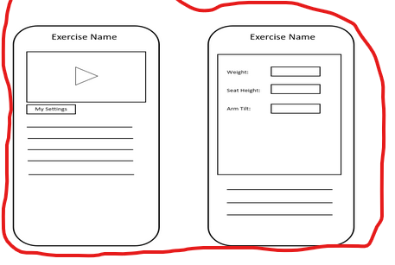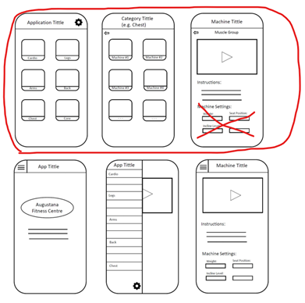

**Formal Requirements Specification**

| **Must:** | **Should:** | **Could:** | **Won’t** |
| --- | --- | --- | --- |
| Include all paramount machines given by client | Google maps link to gym | Make our own videos | Develop for apple devices |
| Have videos for each machine | Get permission from True Fitness to use their videos | Recommendations for new users | Create a map of facility |
| Options menu containing weight and machine adjustments |  | Progression graph that uses weight |  |
| About page concerning contact info for gym |  |  |  |
| Use manufacturer photos |  |  |  |
| Research each machine in its use |  |  |  |
| Create an informative text block for each machine |  |  |  |

**User Interface Screens**

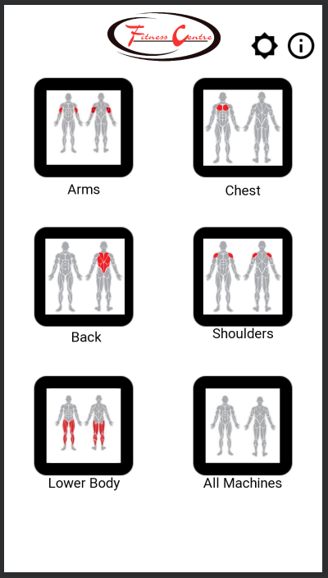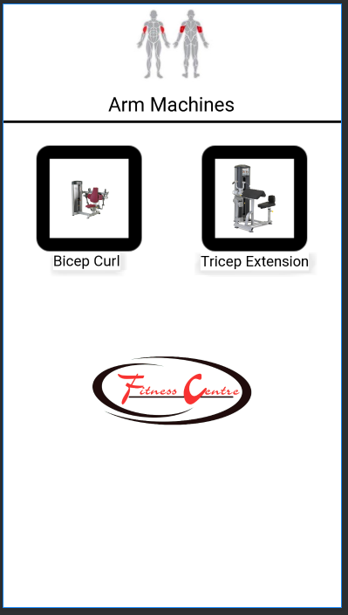

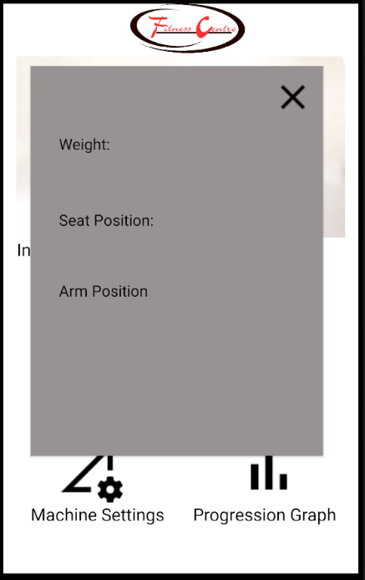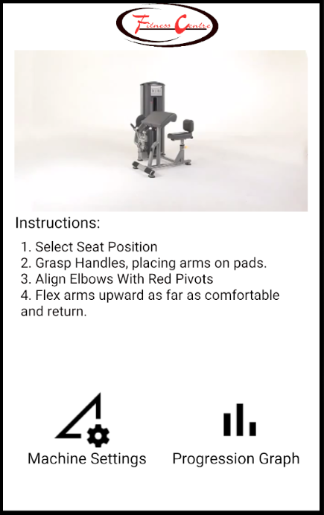

**High Level Design**

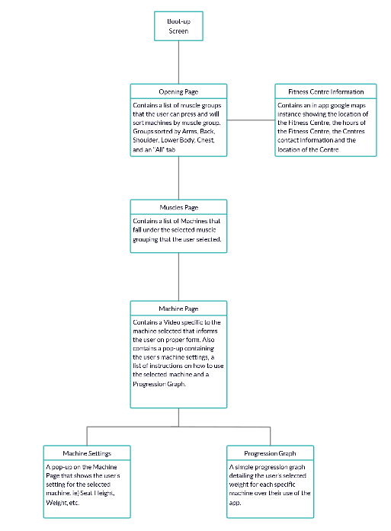

**Basic Architecture**

* Event Driven

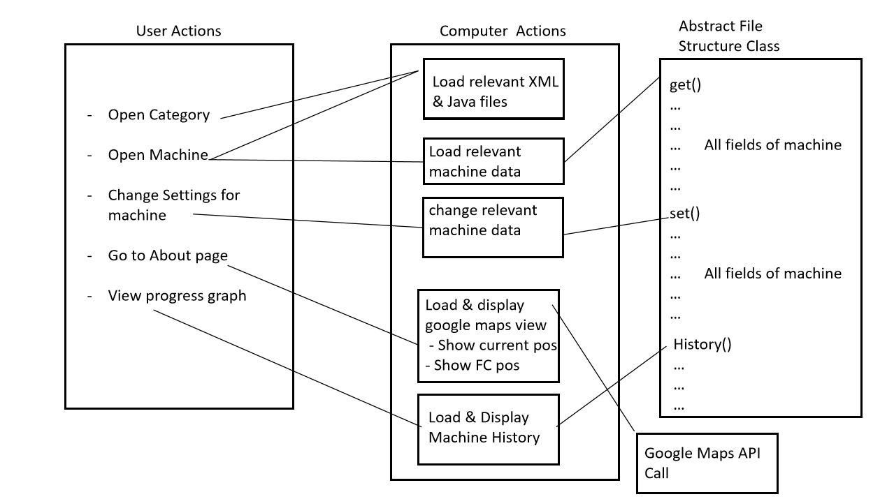

The flow of our application is going to be determined by user actions. More specifically, each user action has an associated computer action which either loads files or uses an external class or structure to access data.

**Coding Standard Adopted**

We are using Google Java style guide and the Google XML document format style guide

https://google.github.io/styleguide/javaguide.html

https://google.github.io/styleguide/xmlstyle.html

**Work Plan**

Our team functions on job boards where each person takes a job if they don’t already have one.

For the next two days our teams’ goals start with finding videos and pictures to accompany each piece of equipment. If a video does not exist we will create said video. We will be putting the appropriate information on the appropriate machine screen. We will be researching each machine in its proper use through online videos, documents and through a personal trainer. On the code side we are looking to finish the code for the stored user settings and to work on implementing the progression graphs. We are also hoping to create a pop-up for first time user information.